ARCHITECT REVIEW
Trouble Ticket Story
Great Plains Merge Sandbox | Read-only dry-run and readiness assessment
Environment | GreatPlainsMerge (Sandbox)
Role | Solution Architect review
Assessment date | 26 August 2026
Decision | Conditional approval - changes requested
Boundary | No record creation, deployment, activation, or metadata changes

ARCHITECT DECISION
Do not promote yet. The core configuration is present, but user-access, Priority field security, Fixed Wireless mapping, and spreadsheet parity require closure.

Acceptance test outcome
TC | Scope | Result | Evidence
1 | Trouble Ticket record type | Pass - current admin | Active, available, default, and mapped to the dedicated layout for the connected administrator.
2 | Layout and required fields | Partial pass | Requested fields exist, but Priority__c is hidden and the layout contains additional unrequested sections/fields.
3 | Dependent picklists | Partial fail | Both chains exist; Fixed Wireless has zero Subscriber Report choices and exact workbook parity is unverified.

Approval position
Recommended status: Changes Requested / Conditional Approval.
The implementation is structurally close, but an architect sign-off should wait until the four approval gates on page 5 are completed and evidenced.

Solution overview
This board shows how the intended NOC user reaches the Trouble Ticket experience and where the current review gates sit.
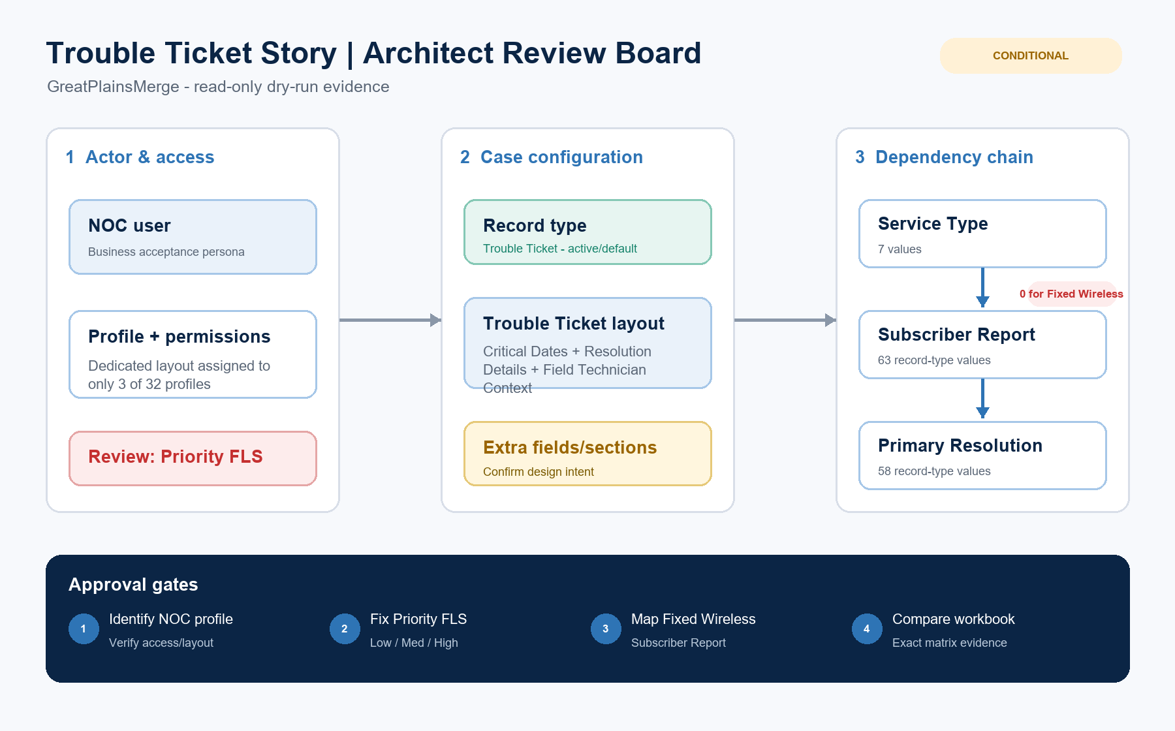
Figure 1. Figma-style architect review board
DESIGN READING
Green/blue items are configured. Amber and red items require confirmation or correction before promotion.

Detailed architect findings

1. Record type and access
Item | Observed | Architect interpretation
Record type | Trouble Ticket | Active; record type ID 012Ea000007eNrVIAU.
Connected user | System Administrator | Trouble Ticket is available and the default Case record type.
Dedicated layout | 3 profiles | System Administrator, System Administrator - API Only, and Standard User.
Default Case layout | 29 profiles | These profiles do not receive the dedicated Trouble Ticket layout assignment.
NOC persona | Not identified | No active profile/user was discoverable by NOC name, department, or title.

2. Layout coverage
Area | Result | Evidence
Critical Dates | Pass with additions | Problem Occurred, Problem Reported, Repair, Created, and Closed Date are present. Created By and MTTR are additional.
Resolution fields | Pass | Primary Resolution, Secondary Resolution, and Resolution Detail are grouped under Resolution Details.
Service context | Pass | Service Type, Service Address, Subscriber Report, Parent Case, and standard Priority are placed on the layout.
Extra section | Review | Field Technician Context was added although it is outside the stated test cases.
Priority ambiguity | Changes requested | Custom Priority__c has Low/Med/High but no field permission. Standard Priority remains visible with High/Medium/Low.

3. Dependency evidence
Relationship | Status | Evidence
Service Type -> Subscriber Report | Configured | 7 Service Types; 63 Subscriber Reports on Trouble Ticket; Fixed Wireless maps to zero.
Subscriber Report -> Primary Resolution | Configured | All available Subscriber Report controllers have at least one Primary Resolution.
Record-type exclusions | Review | LOCATE is excluded from Subscriber Report. Three Primary Resolution values are excluded.
Excel parity | Blocked | The referenced Subscriber Reports NISC workbook was not attached or directly accessible.

Configuration class diagram
The diagram separates user access, Salesforce configuration, record data, and the external mapping source so ownership is clear.
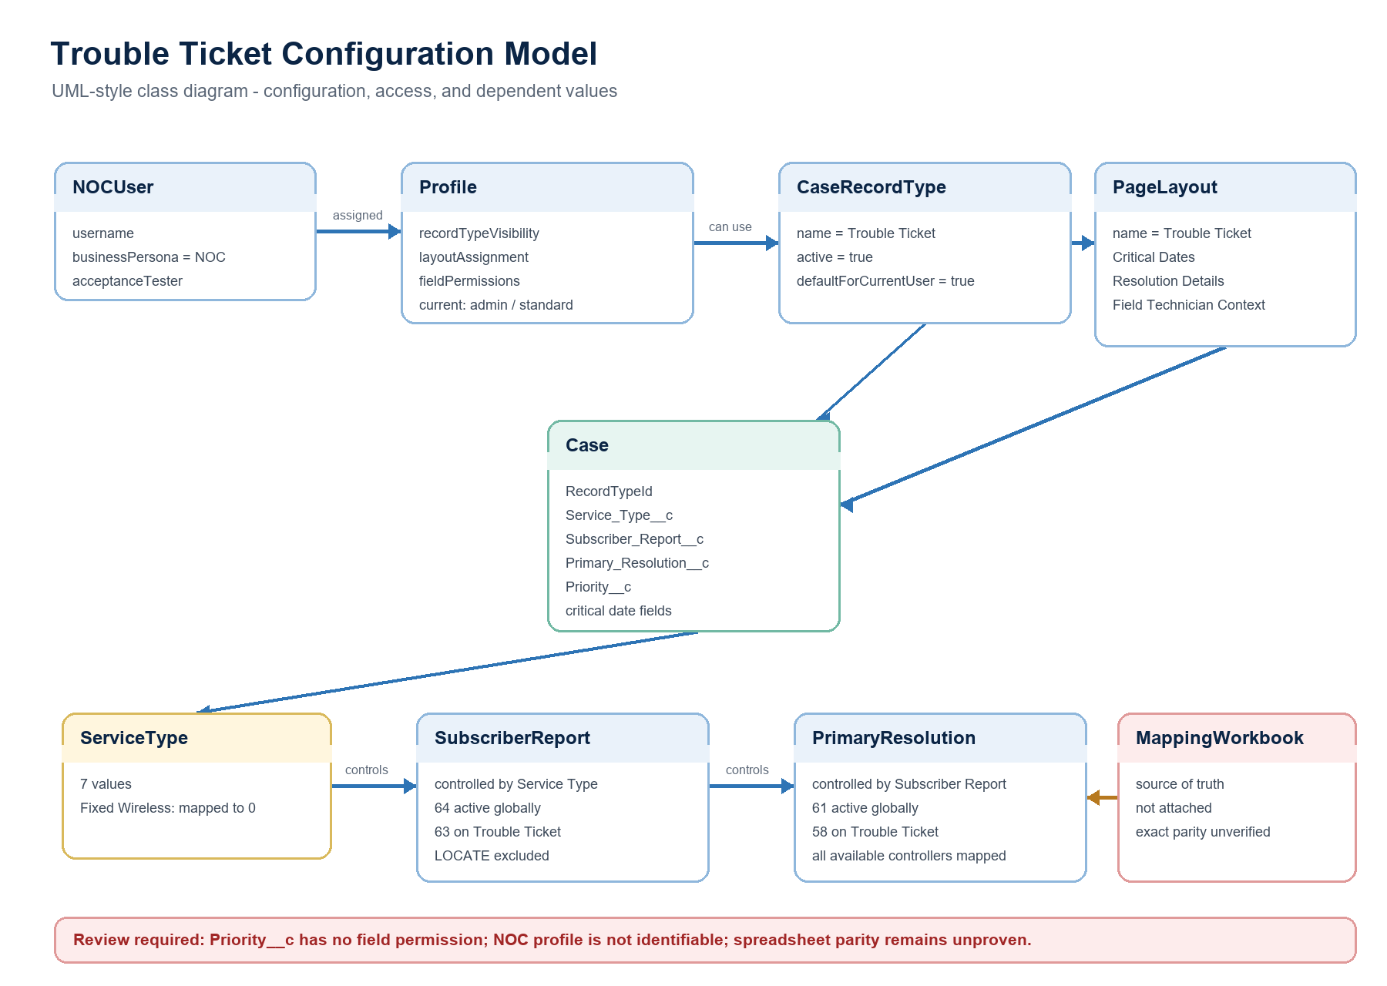
Figure 2. Trouble Ticket configuration and dependency class diagram
Architect interpretation: the Salesforce configuration objects are connected correctly for the current administrator, but the business-persona access model and workbook-driven value parity are not yet proven.

Required approval gates
Gate | Required action | Owner | Evidence needed
1 | Identify the NOC test user/profile | Product owner / Salesforce admin | Provide the username and prove record type, layout, and field visibility.
2 | Resolve Priority field design | Salesforce admin / Architect | Choose standard Priority or custom Priority__c; add field-level access if custom is retained.
3 | Resolve Fixed Wireless mapping | Business analyst / Admin | Add Subscriber Report values or document that an empty list is intentional.
4 | Validate Excel parity | Business analyst / QA | Attach the workbook and compare every Service Type, Subscriber Report, and Primary Resolution mapping.
5 | Confirm layout additions | Product owner / Architect | Approve or remove Created By, MTTR, Resolution Details, and Field Technician Context deviations.

Ready-to-paste architect response
STORY COMMENT
Architect review completed in the GreatPlainsMerge sandbox. The core Trouble Ticket configuration is present, including the active record type, dedicated layout, Critical Dates fields, and both dependent-picklist relationships. Approval remains conditional. Please confirm the intended NOC user/profile assignment, resolve field-level access and usage for the Low/Med/High Priority field, resolve or confirm the empty Fixed Wireless Subscriber Report mapping, provide the Excel workbook for exact dependency validation, and confirm that the additional MTTR, Created By, Resolution Details, and Field Technician Context items are intentional. No records, metadata, activation, or deployment changes were made during this review.

Evidence boundary
This report is a live, read-only configuration review of GreatPlainsMerge as observed on 26 August 2026. It is not a deployment validation, because no local change package or check-only deployment was supplied.

